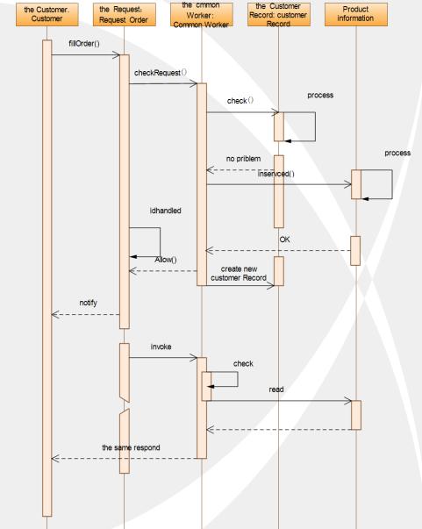

Customers need to rent related products, first customers must find and fill out the relevant rental application form. The back office of the website is responsible for processing the application. Based on the history of the customer's lease and the status of the items leased by the customer, they decide whether to accept the customer's rental application. If both conditions are met, the customer's rental request will be accepted, otherwise they will refuse. The item is leased and the processed application status is set to Processed. If accepting the user's rental needs, the two parties negotiate how to pick up the goods through the website.